Yoga Intro Poses

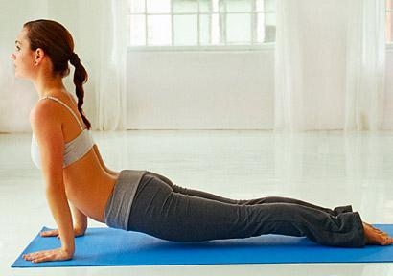
Yoga poses for joint and muscle aches
If you're looking for an alternative to pills to treat joint pain and other common (and uncomfortable) aches, relief may be a yoga class away. A review of 20 years’ worth of studies conducted by researchers at Duke University Medical Center found that yoga is effective in the treatment of chronic pain, including osteoarthritis, carpal tunnel syndrome, and fibromyalgia.
In the studies reviewed, patients saw significant reductions in joint pain, muscle stiffness, and overall physical discomfort while greatly improving their flexibility, range of motion, and muscle strength.
Performed correctly, yoga's fluid movements allow swollen or otherwise painful joints to glide smoothly over one another, increasing mobility and strength without excess wear and tear. Yoga is a safe alternative to weight-bearing exercises that could worsen weak joints because it strengthens the muscles around them, which reduces tension and increases mobility.
We asked yoga instructors for their five favorite poses for relieving knee pain, back pain, and more (talk with your doctor before starting an exercise program and use props such as blocks for support as needed).

Yoga Pose: Cobra
Try it for: Back pain
Lie face-down, forehead resting on floor. Place hands on either side, at middle of ribcage. Draw legs together, pressing tops of feet into floor. Reach back through toes, lengthening legs, and press evenly through hands as you draw elbows close to ribcage. Using strength of back (not arms), lift head and chest, sliding shoulder blades down back. Take 5 to 10 deep breaths before gently releasing to floor, turning head to one side.

Yoga Pose: Supported Warrior
Try it for: Knee pain
Stand tall and place hands against a wall at shoulder height. Step right foot forward so toes touch the wall and bend elbows as though you're trying to push the wall away. Step left foot about 1 to 3 feet behind you, slightly bending left knee toward floor. Hold for 10 to 15 breaths. Slowly straighten left leg while bending right knee, ensuring knee does not extend past ankle. Hold for 10 to 15 breaths before stepping left foot forward to meet right and switching leg positions.

Yoga Pose: Butterfly
Try it for: Hip pain
Sitting on blanket on floor, bring soles of feet together, knees wide so legs form a diamond. Keep entire back straight and shoulders relaxed as you breathe and gently drop weight of legs, slowly allowing knees to lower toward floor. For gentler relief, place blocks or pillows beneath outer knees for support.

Yoga Pose: Rear Arm Lift with Strap
Try it for: Shoulder pain
This stretch is also known as "Standing Yoga Mudra" pose. Stand tall, feet hip-width apart, holding strap in one hand. Sweep both arms behind back and pull shoulders in to grasp strap with both hands in a comfortable position. Walk hands toward each other, creating an opening in chest as shoulder blades move toward one another. Breathe as you adjust shoulders, easing or increasing tension.

Yoga Pose: Wall Plank
Try it for: Elbow and shoulder pain
Stand facing wall with feet hip-width apart. Place palms against wall, arms extended, and slowly lean forward, letting body rest on hands. Keep arms in and body in a straight line as you slowly bend elbows, inching closer. When nose touches wall (or you feel discomfort), slowly push back to standing.

